

**INTO OSU**

**Emergency Operations Plan**

**April, 2018**

**Corvallis, Oregon**

Promulgation, Approval, and Implementation

The following is the Emergency Operations Plan (EOP) for INTO OSU. It identifies procedures and responsibilities for the planning and implementation of emergency procedures (including evacuations) for the protection of life and property.

This plan applies to all visitors, staff, students, volunteers or others working in INTO OSU buildings. All OSU employees/students/volunteers and any non-OSU employee working in OSU buildings are required to become familiar with this plan and follow the plan and the INTO OSU Executive Director (hereafter known as Director) or designated personnel directions during an emergency incident. Personnel will be notified of changes to this plan by their supervisor.

This plan has been approved and adopted by the INTO OSU Executive Director and the INTO OSU Incident Management Team (IMT). It will be revised and updated as required. This plan supersedes any previous plan.

It is understood that emergency plans exist for co-located agencies/building occupants (federal, state); where their plans are absent in instructions, this plan will be in effect.



___________________________________ **______________________**

Bob Gilmour Date

INTO OSU Executive Director

Record of Change

Minor/editorial changes (to correct factual accuracy, update response content to standardize with other agencies, changes to personnel or phone numbers, update of building inventory, etc...) or changes to the appendices can be approved by the INTO OSU Incident Management Team.

**Record of Changes**

|  |  |
| --- | --- |
| Date | Summary of Change |
| May 2018 | Initial Plan published |
|  |  |
|  |  |
|  |  |
|  |  |
|  |  |

Plan Distribution List

Copies of this plan are provided to all organizations located within INTO OSU. Updates will be distributed as they are developed. Distribution will be electronically, unless otherwise indicated on the following distribution list.

| Date | Distribution | |
| --- | --- | --- |
| June 2018 | INTO OSU website  intoosu.oregonstate.edu | Electronic copy |
| April 2018 | OSU Box | Electronic copy |
|  |  | Electronic copy |
|  |  | Electronic copy |
|  |  | Electronic copy |
|  |  | Electronic copy |
|  |  | Electronic copy |
|  |  | Electronic copy |
|  |  | Electronic copy |
|  |  | Electronic copy |
|  |  | Electronic copy |
|  |  | Electronic copy |
|  |  | Electronic copy |
|  |  | Electronic copy |
|  |  | Electronic copy |
| June 2018 | Welcome Desk | Paper copy |
|  |  | Paper copy |
|  |  |  |
|  |  |  |
|  |  |  |

Table of Contents

1. Purpose 7

2. Scope 7

3. Overview 7

4. Planning Assumptions 9

5. Concept of Operations 9

6. Organization and Assignment of Responsibilities 9

Oversight 10

Preparedness Team 10

Response Team 10

Recovery Team 11

7. Direction and Control 12

a. Decision-making 12

b. Control 12

8. Communications 12

9. Plan Maintenance 13

Appendix A Communication Contact Lists 15

Appendix B Abbreviations and Acronyms 17

Appendix C INTO OSU Hazard Analysis 18

Appendix D INTO OSU Communication Plan 21

Appendix E INTO OSU Closure Plan 22

Appendix F Emergency Action Plans 23

Disaster - Natural or Human Caused 23

Evacuation 25

Evacuation Map (non-tsunami) 29

Evacuation Map (tsunami) 35

Shelter in place / Lock Down 36

Fire/Explosion 38

Medical Injury 41

Poisoning 43

Chemical Spill 45

Radiological Material Spill 47

Transportation Accidents 49

Severe Weather 51

Earthquake/Tsunami 53

Building Systems (Utilities) 56

Crimes in Progress 58

Sexual Assault 59

Active Shooter 60

Hostage 63

Bomb Threat 64

Bomb Threat Checklist 66

Bomb/Suspicious Object 67

Disruptive Student 68

# Purpose

This plan establishes procedures and responsibilities in which INTO OSU employees/volunteers/students and, if necessary, co-located agencies/building occupants can plan for and respond to various emergencies that require protection of life, research, academic viability, and property.

During an emergency, INTO OSU will rely on this plan’s prescribed procedures to effectively implement response, organizational issues, communications and decision making processes.

# Scope

This plan applies to:

* All OSU affiliated personnel within INTO OSU (faculty, staff, students, volunteers, etc…)
* All non-OSU personnel working within OSU INTO OSU buildings (other agencies, volunteers, etc…)
* Visitors at INTO OSU sponsored functions (e.g. picnics, guest lecturers, school group visits, clients, patients, etc…)

# Overview

Oregon and OSU are subject to natural, manmade, and security emergencies that could occur at any time. The impact of these hazards could range from a minor/temporary disruption of daily operations to catastrophic/long-term disruption of operations with the potential of loss of life. Some of these events may be prevented or their impact reduced through mitigation and planning activities. In the event the emergency/incident does occur, the immediate safety and initial response and rapid recovery will rely solely on the level of preparedness of faculty, staff and students.

INTO OSU is a major educational element for OSU. Students and faculty live at or within commuting distance of the OSU campus. Additionally, INTO OSU hosts visitors throughout the year. The population demographic is inclusive of all ages, various levels of mobility, a wide range of disabilities, limited English language skills, and other attributes that require pre-active response planning.

This plan was developed with input from multiple INTO OSU campus partners, city and county emergency management officials, and Oregon State University officials.

This plan addresses emergency preparedness activities that take place during the four phases of emergency management. The four phases are: Mitigation, Preparedness, Response, and Recovery.

1. Mitigation

INTO OSU will conduct mitigation activities as part of the emergency management program. Mitigation is intended to eliminate hazards, reduce the probability of hazards causing an emergency situation, or lessen the consequences of unavoidable hazards. Mitigation should be a pre-disaster activity, although mitigation may also occur in the aftermath of an emergency situation with the intent of avoiding repetition of the situation.

1. Preparedness

Preparedness activities will be conducted to develop the response capabilities needed in the event of an emergency. Colleges, departments, and offices must develop plans and procedures to assist in the overall implementation and maintenance of emergency plans. Among the preparedness activities included in the emergency management program are:

* Providing emergency equipment and facilities
* Emergency planning, including maintaining this plan, its appendices, and appropriate SOPs
* Conducting or arranging appropriate training for emergency responders, emergency management personnel, other local officials, and volunteer groups who assist this jurisdiction during emergencies
* Conducting periodic drills and exercises to test emergency plans and training

1. Response

INTO OSU will respond to emergency situations effectively and efficiently. The focus of most of this plan and its appendices is on planning for the response to emergencies. Response operations are intended to resolve a situation while minimizing casualties and property damage.

1. Recovery

If a disaster occurs, INTO OSU will carry out a recovery program that involves both short-term and long-term efforts. Short-term operations seek to restore vital services to the university community. Long-term recovery focuses on restoring the university to its normal state. The federal government, pursuant to the Stafford Act, provides the vast majority of disaster recovery assistance. The recovery process includes assistance to individuals, businesses, and government and other public institutions. Examples of recovery programs include temporary housing, restoration of university services, debris removal, restoration of utilities, disaster mental health services, and reconstruction of damaged roads and facilities.

Hazards were identified and response guidelines developed to ensure the protection of resources before, during, and after emergency situations.

# Planning Assumptions

* Events will occur with no notice
* OSU staff, faculty, and volunteer personnel are familiar with their responsibilities to themselves and the public/students during emergency situations
* Procedures in this EOP are for OSU personnel; efforts are taken to ensure that campus partner emergency procedures and plans are consistent with this EOP
* The four phases of emergency management are applied to each identified emergency

# Concept of Operations

A basic premise of emergency management is that incidents are handled at the lowest jurisdictional level possible. Emergency preparation and response begins at the College, School, or Department level. Each work unit will have to prepare for and respond to events. The OSU Emergency Operation Center will coordinate University level response and allocation of resources so that other College, School, or Departments can request assistance when the incident depletes or exceeds internal capabilities.

An incident (small or large scale) occurs that disrupts INTO OSU operations. Notification is made internally to the responsible authority, who determines what level of response is necessary.

If the incident response exceeds INTO OSU capability, the responsible authority contacts OSU resources for support. Typically, this is escalated to the Public Safety Dispatch Center or appropriate maintenance coordination center These initial answering point agencies will direct response resources, or request activation of the OSU Emergency Operation Center (EOC) for response coordination.

The College/School/Department should identify “Essential Personnel” who are essential to the continued operations during curtailment or closure of operations. These personnel should be notified of their role and expectations to report to work during emergency situations.

# Organization and Assignment of Responsibilities

The following structure and key personnel are responsible for the planning, preparedness, and implementation of emergency management activities for INTO OSU.

## Oversight

The INTO OSU Executive Director is responsible for the safety and protection of life, securing critical infrastructure, and timely resumption of teaching, research, and business activities. Three teams with designated responsibilities will carry out these activities.

## Preparedness Team

* INTO OSU Incident Management Team (IMT) (with guidance from the Director) will be responsible for making sure that plans, emergency equipment, and infrastructure to deal with an emergency are in place.
* INTO OSU IMT will convene meetings/ seminars and prepare summary materials to increase staff awareness of the content of this plan.
* The IMT consists of: Human Resource Manager, Senior Coordinator for Care and Conduct, Senior Coordinator for Engagement and Operations, Executive Assistant to the Executive Director, and the Executive Assistant to the Director of Academic Programs.

## Response Team

This team coordinates the emergency response. The Response Team is comprised of the following members:

* INTO OSU Executive Director
  + Organize INTO OSU response command and control structure. The Incident Command System is one of several incident management structures available for use.
  + Communicates with OSU Emergency Operation Center
  + Determines level of response, Level 1 Green, Level 2 Yellow, Level 3 Orange.
  + Communicates with the OSU Dept. of Public Safety (541-737-3010)
  + Communicates with the OSU Vice President/Provost, if needed
  + Communicates with members of the Response Team
  + Initiates communication to inform INTO OSU personnel of a closure
* INTO OSU Incident Management Team
* INTO OSU Building Manager/UHDS Resident Director
  + Ensures all essential staff are on-site
  + Will direct evacuation (via fire alarm pull station) if necessary
* INTO OSU Marketing and Communication Specialist
  + Posts the message on the INTO OSU website
  + Updates the message on social media
* INTO OSU Welcome Desk and Director of Academic Programs
  + Notifies affected instructors, graduate and undergraduate students, intern programs and visiting colleges/universities of the current situation

## Recovery Team

The purpose of this group is to restore teaching, research and business functions in a timely manner. The Recovery Team is comprised of:

* INTO OSU Executive Director
* INTO OSU Finance Business Partner
* UHDS Resident Director
* IMT -- INTO OSU Senior Coordinator for Engagement and Operations
* IMT -- INTO OSU Human Resource Manager
* IMT -- INTO OSU Senior Coordinator for Care and Conduct
* IMT -- INTO OSU Exec. Asst. to the Director of Academic Programs
* IMT – INTO OSU Exec. Asst. to the Executive Director

# Direction and Control

## Decision-making

When an incident occurs, each individual is responsible for immediate life safety response of themselves and personnel under their care. This could include such actions as: calling 9-1-1, evacuating the immediate area, activating the fire alarm, and (depending upon level of training) providing first aid or extinguishing fires.

The INTO OSU Executive Director, or designated representative, is responsible for approving resources or communicating assistance requests to the appropriate OSU Administration official or the EOC (if activated).

INTO OSU designates the following line of succession in the absence of the Director:

1. INTO OSU Director of Academic Programs
2. INTO OSU Director of International Admissions & Academic Support
3. INTO OSU Director of Student Experience

## Control

The INTO OSU Incident Management Team is responsible for the coordination of INTO OSU response resources to the incident.

The INTO OSU Incident Management Team will organize and coordinate incident response from the following location:

1. INTO OSU Executive Director’s Office, ILLC Room 174 (541-737-4287)
2. Cascade Hall 1st floor, available room/space

# Communications

Several avenues exist for communication to INTO OSU staff, faculty, students, and volunteers. Depending upon the extent/level of situation, multiple communication paths may be used to ensure personnel are kept informed:

* Telephone
* Cell phone
* E-mail
* Video/TV display boards
* Bulletin boards, located throughout the building
* Social Media
* OSUAlert – if a university wide incident

# Plan Maintenance

The INTO OSU EOP is developed through the INTO OSU Incident Management Team. The INTO OSU Executive Director and INTO OSU Incident Management Team are responsible for coordinating plan development and changes as necessary.

The Appendices to the EOP provide supporting information and response guidance for identified hazards.

The plan will be updated as necessary, based upon periodic reviews, improvement items identified from drills or actual incident responses, and changes to the threat environment.

The plan will be reviewed and re-promulgated every three years.

Questions about this plan should be directed to the INTO OSU Incident Management Team.

Appendices

1. Communication Contact List
2. Abbreviations and Acronyms
3. INTO OSU Hazard Analysis
4. INTO OSU Communications Plan
5. INTO OSU Closure Plan
6. Emergency Action Plans
7. Disaster – Natural or Human Caused
8. Evacuation
   1. Evacuation Map (non-tsunami)
   2. Evacuation Map (tsunami)
9. Shelter in Place / Lock down
10. Fire/Explosion
11. Medical Injury
12. Poisoning
13. Hazardous Materials
    1. Chemical spill
    2. Radiological material spill
14. Transportation Accidents
15. Natural Hazards
    1. Weather
    2. Earthquake
    3. Tsunami
16. Utility Failures
17. Threat of Violence
    1. Bomb Threat (w/ checklist)
    2. Bomb/Suspicious Object
    3. Suspicious person
    4. Hostage
    5. Active Shooter
18. Terrorism
19. Interpersonal emergencies
    1. Disruptive student
20. Unit Specific Response Plans for Unit Specific Operations/responsibilities

# Appendix A Communication Contact Lists

|  |  |  |
| --- | --- | --- |
| Important Phone Numbers  (<http://oregonstate.edu/dept/security/emergency-phone-numbers>_  Post This Page Near Your Phone | | |
|  | On Campus | Off-Campus |
| POLICE / FIRE / Emergency Medical Assistance | 9-1-1 | 9-1-1 |
| OSU Oregon State Police  (Emergency) | 7-7000 | 541-737-7000 |
| OSU Department of Public Safety & Oregon State Police  (Non-Emergency) | 7-3010 | 541-737-3010 |
| Corvallis City Police  (Non-Emergency) | 9-541-766-6911 | 541-766-6911 |
| Corvallis City Fire  (Non-Emergency) | 9-541-766-6911 | 541-766-6911 |
| GSRMC Hospital | 9-541-768-5111 | 541-768-5111 |
| Executive Director’s Office | 7-2464 | 541-737-2464 |
| Oregon Poison Control Center | 9-1-800-222-1222 | 1-800-222-1222 |
| Center Against Rape & Domestic Violence (CARDV) | 9-541-754-0110 | 541-754-0110 |
| Crisis Intervention (Counseling and Psychological Services CAPS) | 7-2131 | 541-737-2131 |
| Student Health Center | 7-WELL (9355) | 541-737-9355 |
| Student Health Center (After hours and on weekends) | 7-2724 | 541-737-2724 |
| OSU Environmental, Health & Safety (EH&S) | 7-2273 | 541-737-2273 |

**Emergency Contact List**

| Title/Position | Name | Work Phone | Cell Phone |
| --- | --- | --- | --- |
|  |  |  |  |
|  |  |  |  |
|  |  |  |  |
|  |  |  |  |
|  |  |  |  |
| **For the Personal Contact information for the INTO OSU Emergency Contact List, contact the employee’s supervisor.** |  |  |  |
|  |  |  |  |
|  |  |  |  |
|  |  |  |  |
|  |  |  |  |
|  |  |  |  |
|  |  |  |  |
|  |  |  |  |
|  |  |  |  |
|  |  |  |  |
|  |  |  |  |
|  |  |  |  |
|  |  |  |  |
|  |  |  |  |
|  |  |  |  |
|  |  |  |  |
|  |  |  |  |
|  |  |  |  |
|  |  |  |  |
|  |  |  |  |
|  |  |  |  |
|  |  |  |  |
|  |  |  |  |
|  |  |  |  |
|  |  |  |  |
|  |  |  |  |

# Appendix B Abbreviations and Acronyms

|  |  |
| --- | --- |
| Abbreviation | Definition |
| CAPS | OSU Counseling and Psychological Services |
| CARDV | Center Against Rape & Domestic Violence |
| EOC | Emergency Operations Center |
| EOP | Emergency Operations Plan |
| EH&S | OSU Environmental, Health and Safety |
| IMT | Incident Management Team |
| OSP | Oregon State Police |
| OSU | Oregon State University |
| WCC | Work Coordination Center |
|  |  |
|  |  |
|  |  |
|  |  |
|  |  |
|  |  |
|  |  |
|  |  |

# Appendix C INTO OSU Hazard Analysis

The incident planning checklist outlines potential emergencies that may be encountered by INTO OSU and should be addressed when developing criteria for planning for specific events.

Review each of the criteria and evaluate the criteria as the incident was to impact your area of responsibility.

The calculated scores will help identify which events have the greatest impact and require more emergency management activity to prepare for the incident.

|  |  |  |  |  |  |
| --- | --- | --- | --- | --- | --- |
| Occurred to department or has high potential to do so (5) annually, (4) last 2-5 yrs, (3) last 5-10 yrs, (2) last 10-25 yrs, (1) > 25 yrs | Effect the hazard has to the Health and Welfare majority of people within your institution (5) Life threatening, (4) Health/Safety threat, (3) Psychological Disruption, (2) Disruption of ability to do job 24 hrs, (1) Disruption of ability to do job <8 hrs | Vulnerability to research operations (3) High risk (2) Medium risk (1) Low risk | Vulnerability of academic operations (3) High risk (2) Medium risk (1) Low risk | Effect the hazard has to physical infrastructure within your institution (3) Disruption to most services > 12 hrs, (2) Disruption to some services 6-12 hrs, (1) Disruption to a few services < 6 hrs | Assessment Score = Occurrence * H&S * Research * Academic * Property |

|  | **Occurrence Score** | **Health & Safety** | **Research** | | **Academic Operations** | **Property & Environment** | **Assessment Score** |
| --- | --- | --- | --- | --- | --- | --- | --- |
| **Fire Emergencies** |  |  |  |  | |  |  |
| Minor Fire - 1 room | 5 | 1 | 1 | 1 | | 1 | 5 |
| Major Fire - 3 or more rooms | 1 | 2 | 2 | 1 | | 1 | 4 |
| Explosion | 1 | 3 | 3 | 2 | | 2 | **36** |
| **Medical Emergencies** |  |  |  |  | |  |  |
| Death/Homicide | 4 | 3 | 1 | 1 | | 1 | 12 |
| Injury | 5 | 1 | 1 | 1 | | 1 | 5 |
| Food Poisoning | 1 | 2 | 1 | 2 | | 1 | 4 |
| Mass Casualties | 1 | 3 | 1 | 2 | | 1 | 6 |
| Disease Outbreak | 1 | 4 | 2 | 3 | | 1 | 24 |
| Odors | 1 | 1 | 2 | 2 | | 1 | 4 |
| Animal | 1 | 1 | 1 | 1 | | 1 | 1 |
| **Hazardous Materials** |  |  |  |  | |  |  |
| Material Release (air) | 1 | 1 | 1 | 1 | | 1 | 1 |
| Spill/Exposure | 1 | 1 | 1 | 1 | | 1 | 1 |
| Radiation Exposure | 1 | 1 | 1 | 1 | | 1 | 1 |
| Asbestos Release | 1 | 1 | 1 | 1 | | 1 | 1 |
| Biological exposure | 1 | 1 | 1 | 1 | | 1 | 1 |
| **Transportation Accidents** |  |  |  |  | |  |  |
| Automobile Accident | 1 | 1 | 1 | 1 | | 1 | 1 |
| Aircraft Collision with Building | 1 | 5 | 3 | 3 | | 3 | **135** |
| Pedestrians/Bicyclists | 5 | 1 | 1 | 1 | | 1 | 5 |
| Non-road vehicle (Tractor/farm) | 1 | 1 | 1 | 1 | | 1 | 1 |
| Maritime/Aviation | 1 | 1 | 1 | 1 | | 1 | 1 |
| **Evacuation** |  |  |  |  | |  |  |
| Sporting Events | 1 | 1 | 1 | 1 | | 1 | 1 |
| Planned Events | 1 | 1 | 1 | 2 | | 1 | 2 |
| Building Evacuation | 5 | 1 | 1 | 1 | | 1 | 5 |
| Shelter-in-place | 1 | 3 | 1 | 1 | | 1 | 3 |
| **Natural Hazard** |  |  |  |  | |  |  |
| University Closure | 5 | 1 | 1 | 3 | | 1 | 15 |
| Flooding | 5 | 1 | 1 | 1 | | 1 | 5 |
| Ice/Snow Storm | 5 | 1 | 1 | 2 | | 1 | 10 |
| High Wind/Tornado | 1 | 4 | 1 | 3 | | 3 | **36** |
| Earthquake/Tsunami | 1 | 5 | 3 | 3 | | 3 | **135** |
| **Utilities/Infrastructure** |  |  |  |  | |  |  |
| Telephone/Telecom Failure | 1 | 1 | 1 | 1 | | 1 | 1 |
| Electrical Failure | 2 | 1 | 1 | 3 | | 1 | 6 |
| Loss of Water Availability | 2 | 1 | 2 | 1 | | 1 | 4 |
| HVAC Failure | 1 | 1 | 1 | 1 | | 1 | 1 |
| Hood Ventilation Failure | 1 | 1 | 1 | 1 | | 1 | 1 |
| IT Failure - Data transmission | 1 | 1 | 1 | 3 | | 1 | 3 |
| IT Server Hardware failure | 1 | 1 | 1 | 3 | | 1 | 3 |
| Structural Failure | 1 | 2 | 2 | 3 | | 2 | 24 |
| **Threat of Violence** |  |  |  |  | |  |  |
| Bomb Threat | 4 | 3 | 2 | 2 | | 1 | **48** |
| Bomb/Suspicious Object | 4 | 3 | 2 | 1 | | 1 | 24 |
| Campus Violence/Suspicious Person | 5 | 3 | 2 | 1 | | 1 | 30 |
| Weapons | 5 | 3 | 2 | 1 | | 1 | 30 |
| Vandalism | 1 | 3 | 2 | 1 | | 1 | 6 |
| Hostage Situation | 1 | 3 | 2 | 1 | | 1 | 6 |
| Active Shooter/Lock Down | 1 | 3 | 2 | 3 | | 1 | 18 |
| Bias Incident | 5 | 3 | 2 | 1 | | 1 | 30 |
| **Terrorism** |  |  |  |  | |  |  |
| National/State Level | 2 | 3 | 1 | 1 | | 1 | 6 |
| Local Level | 3 | 3 | 1 | 1 | | 1 | 9 |
| **Interpersonal Emergencies** |  |  |  |  | |  |  |
| Sexual Assault | 5 | 3 | 2 | 1 | | 1 | 30 |
| Stalking | 5 | 3 | 2 | 1 | | 1 | 30 |
| Relationship/workplace Violence | 1 | 3 | 2 | 1 | | 1 | 6 |
| Missing Student/Staff | 5 | 3 | 2 | 1 | | 1 | 30 |
| Study Abroad Incident | 1 | 1 | 1 | 1 | | 1 | 1 |
| Suicide | 1 | 3 | 3 | 1 | | 1 | 9 |

# Appendix D INTO OSU Communication Plan

1. See Appendix A for contact name and phone numbers
2. INTO OSU Executive Director or designee receives communication from OSU or needs to notify INTO OSU members.
3. INTO OSU Executive Director notifies:
4. INTO OSU Management Team
5. INTO OSU Marketing and Communication Specialist
   * Posts message to INTO OSU web page and social media
6. INTO OSU Senior Coordinator, Care and Conduct
   * Notifies OSU Dept. of Public Safety: 541-737-3010 (and/ or email to: [public.safety@oregonstate.edu](mailto:public.safety@oregonstate.edu)) for dissemination to the OSU Web page and “Quick Check” weather hotline
7. INTO OSU Welcome Desk and Director of Academic Programs
   * Notifies affected instructors, students and interns
8. OSU Provost or VP for Finance & Admin
9. OSU VP of University Relations and Marketing
10. Contingencies
11. Telephone outages should be anticipated, and staff should be advised to check more than one source (e.g., web, radio) for confirmation of information.

# Appendix E INTO OSU Closure Plan

If circumstances require emergency closure of INTO OSU, the following procedures shall be followed to ensure maintenance of essential services and effective communication to employees, students, and volunteers.

1. **Decision-making**

The decision to change the hours of operation for INTO OSU on any given day (or to open late or close early) due to an emergency rests with the INTO OSU Executive Director, with communication to the Department of Public Safety and Vice President of Finance and Administration.

* 1. In cases where the INTO OSU Executive Director is on travel and unreachable, the person with designated signatory authority (assigned by the Director prior to commencing travel) shall make such decisions.
  2. If no one is designated during the temporary travel/absence or the designee cannot be reached, the following are to be contacted, in order:
     1. Primary designee: INTO OSU Director of Academic Programs
     2. Secondary designee: Any INTO OSU Director is authorized to make such a decision, which will activate the Response Team.
     3. Tertiary designee: Any INTO OSU Management team member

1. **INTO OSU Notification**
2. Decisions on INTO OSU campus closure will follow the procedures outlined above.
3. Notification of any delayed opening or closure shall be communicated immediately by activating Appendix D – Communication Plan
4. Internal communication methods to reach appropriate personnel
   * + - Call trees
       - Email lists
       - Electronic message boards
       - Web Site
       - Social Media
5. After an all-clear has been received or normal operations can resume, the INTO OSU Executive Director will notify the Response Team and have them use the Communication process to inform personnel that they may return to INTO OSU.

# Appendix F Emergency Action Plans

## Disaster - Natural or Human Caused

**Mitigation:**

* INTO OSU annually reviews and updates portions of plan
* INTO OSU conducts periodic education of plan to faculty and staff to ensure knowledge of responsibilities

**Preparedness:**

* OSU has developed a plan that addresses the campus emergency management system for extraordinary situations that are likely to have a catastrophic effect on the normal functioning of OSU facilities and the surrounding area.
* The INTO OSU Emergency Operation Plan has been developed to respond to the needs of INTO OSU during a disaster and will be placed into operation by the INTO OSU Director when an incident reaches proportions beyond the capacity of routine procedures.
* When the INTO OSU disaster/emergency operation plan is activated, with the exception of an earthquake and/or tsunami, the INTO OSU Disaster Operations Center will be the INTO OSU Assistant Center Director’s Office.
* If the telephone system is not operational, alternate communication methods will be established by INTO OSU.

**Response:**

**Police: Call 7-7000**

**INTO OSU Welcome Desk: Call 541-737-2464**

**INTO OSU Senior Coordinator, Care and Conduct: Call 541-602-3513**

1. Remain calm.
2. To report unsafe conditions, contact the Welcome Desk. Need for medical or law enforcement assistance, call 9-1-1 and the INTO OSU Senior Coordinator, Care and Conduct.
3. Render first aid if you are properly trained.
4. Listen for announcements or alarms and follow instructions from emergency response personnel.
5. Don’t use the elevator during an emergency, use the stairs.

* If you are stranded in an elevator, use the emergency phone/intercom to summon help

1. Don’t drink the water, use gas or electric devices until the emergency personnel determined that it is safe to do so.
2. Do not attempt to fight a fire until after you have notified 9-1-1 that there is a fire, have obtained fire extinguisher training, and feel safe to do so.

**Recovery:**

* Check in with INTO OSU leadership to determine response status
* Do not enter a building until allowed to do so
* Once entering the building, inspect your work area and report any issues

**Appendix F  
Emergency Action Plans**

## Evacuation

**Mitigation:**

* Follow Evacuation planning policy and procedures, as outlined in the Oregon State University (OSU) Safety Policy and Procedure manual <http://oregonstate.edu/fa/manuals/saf/204>
* Identify personnel who are to remain to operate critical plant operations prior to evacuation and develop detailed instructions that include evacuation threshold criteria
* Identify personnel who are responsible for rescue or emergency aid.
* Have a representative participate on the Building Manager’s Evacuation Committee to assist with planning and identifying areas of concern

**Preparedness:**

* Learn where the closest two evacuation points are
* Learn where the evacuation assembly point is
* Learn where fire alarm pull stations are in your area
* Learn where emergency equipment is located, in the event you have to take it with you as you evacuate
* Pre-identify personnel who may have existing conditions that necessitate assistance during an emergency or evacuation.
* Report to INTO OSU Welcome Desk any obstructions or limitations to evacuation routes
* Do not block open fire doors.
* Develop an evacuation kit or identify items to take with you as you evacuate
  + Keys
  + Coat/jacket
  + Pocketbook
  + Medication
  + Appropriate footwear
  + Emergency contact numbers
* Review your workplace and identify areas that must be addressed before evacuating
  + Valuables that must be locked
  + Gases that must be turned off
  + Apparatus that need to be placed into a safe configuration
  + Animals
* Create position specific duties for staff members to perform and train staff members (e.g. HR record security, cashbox, instrument security/shutdown)
* Review building specific emergency or evacuation plans

**Response:**

**Emergency: Call 9-1-1**

When you receive the notice to evacuate the building, or you decide to evacuate due to a nearby danger:

1. Immediately obey evacuation alarms and orders to evacuate.

* Classes in session must evacuate
* OSU employees are to ensure students, visitors, visiting vendors and guests to the campus are evacuated

1. If time allows and without endangering yourself,

* Place equipment in a safe configuration
* Close doors and windows
* Inform others in your vicinity of the current situation
* Take any personal items you may need

1. Leave the building - do not use elevators.

* Use the nearest, safest exit
* Warn others as you evacuate, but do not delay your own evacuation
* All personnel are to exit the building

1. Assist persons with mobility or other evacuation concerns

* Students, staff and visitors who are blind should be assisted through hallways and down stairways
* Wheelchair bound persons should follow evacuation routes on the ground floor of a building. If not on the ground floor, wheel to the nearest assembly area (fire escape or stairway door). Rescue personnel will search these areas first, and help individuals with disabilities evacuate the building.
  + If no pre-identified area, go to an area that provides a barrier between you and the hazard
  + Communicate with responders
  + Dial 9-1-1 or OSU Public Safety (737-7000)
  + Place a cloth or clothing out a window to attract attention
  + Notify others who are evacuating to inform responders of your location

1. Take your cell phone, valuables, and evacuation kit with you.
2. Proceed outside the building to the evacuation assembly area. All personnel should move as far away from the building as practical, so as not to be in danger or in the way of emergency responders. (minimum 50 feet away)

* If the evacuation assembly area is not suitable, follow the directions of the Resident staff or Floor Monitor to move to another area.
* In the event of an earthquake, the evacuation assembly area may be too close to buildings or other objects that could fall. Move to the nearest open space/field to assemble.

1. Conduct accountability for personnel under your supervision.
2. Wait for official notice before attempting to re-enter the building.
3. Report problems or concerns to the INTO OSU Management Team.

**Classroom / Lab Instructors**

1. Proceed outside the building to the evacuation assembly area
2. Direct the class to exit through the nearest safest exit
3. Assign two individuals for each student with disabilities to assist in their safe evacuation from the building
4. Check the classroom/lab area to ensure evacuation is complete prior to exiting the area
5. Once outside, check to see that no one is missing. Report status to a Floor Monitor or INTO OSU Management Team member.

**Building Manager/RD /College point of contact**

1. Take clipboard with check-sheet, building map and cell phone/radio and report to the Evacuation Area
2. Gather accountability status from Floor Monitors
3. Forward accountability information to the Fire Department Incident Commander.

* Include injuries, etc. Use radio, cell phone or dispatch runner

1. Maintain order at Evacuation Area-provide periodic incident updates to personnel
2. When the IC have given the "All Clear," ensure all personnel at the Evacuation Area are made aware of the message

**Floor Monitor Staff**

| **Building** | **Zone** | **Primary Floor Monitor** | **B/U Floor Monitor** |
| --- | --- | --- | --- |
| INTO OSU | 1st Floor – Learning Center | Mamta Chowdhury | Danielle Franklin |
| 1st Floor – Welcome Desk | Ryan Fritz | Hakim Ishak |
| 1st Floor – W | Peets Coffee | Cascadia Market |
| 1st Floor - N | Laurie LeRiche | Ayumi Giampietro |
| 1st Floor - E | Erin Wirkkala | Angie Portz |
| 2nd Floor | Erich Cutler | Elena Sapp |
| 3rd Floor | Ernie Shirosky | Jerry Archer |
| 4th Floor | Tony Zak | Ariana Van Beurden |
| 5th Floor | Rich Hahn | Erich White |
| ILLC | Each Floor | RAs | RAs |

1. Take clipboard with check-sheet, building map and cell phone/radio
2. Conduct "Accountability Check" (negative or positive (depending upon procedure)) within area of responsibility:

* Sweep designated area (including bathrooms, closed doors, etc.)
* Notify building occupants to evacuate building
* Report accountability for area of responsibility to Building Manager/ RD
* Identify if persons needing assistance are still inside building
* Monitor building access points to prevent re-occupation

1. Report to Evacuation Area and assist Building Manager/RD as necessary

**Recovery:**

* Check in with INTO OSU leadership to determine response status
* Do not enter a building until allowed to do so
* Once entering the building, inspect your work area and report any issues

#### Evacuation Map (non-tsunami)

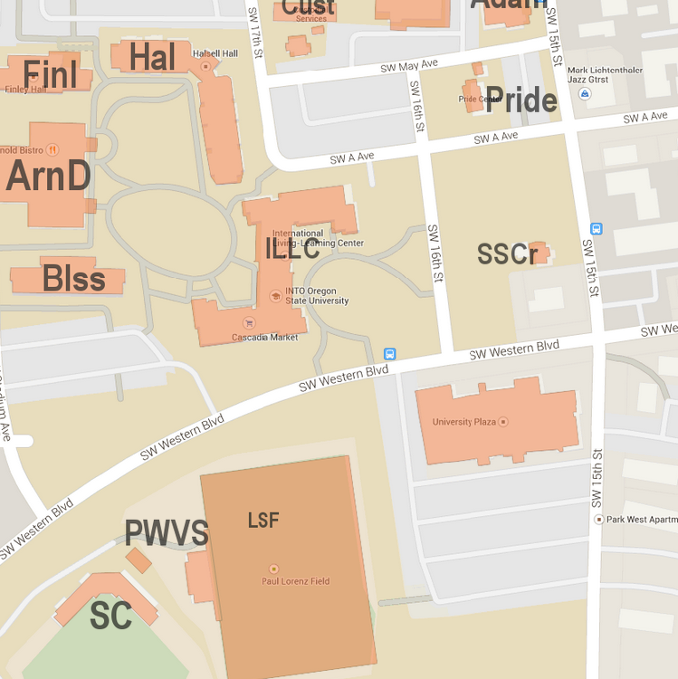

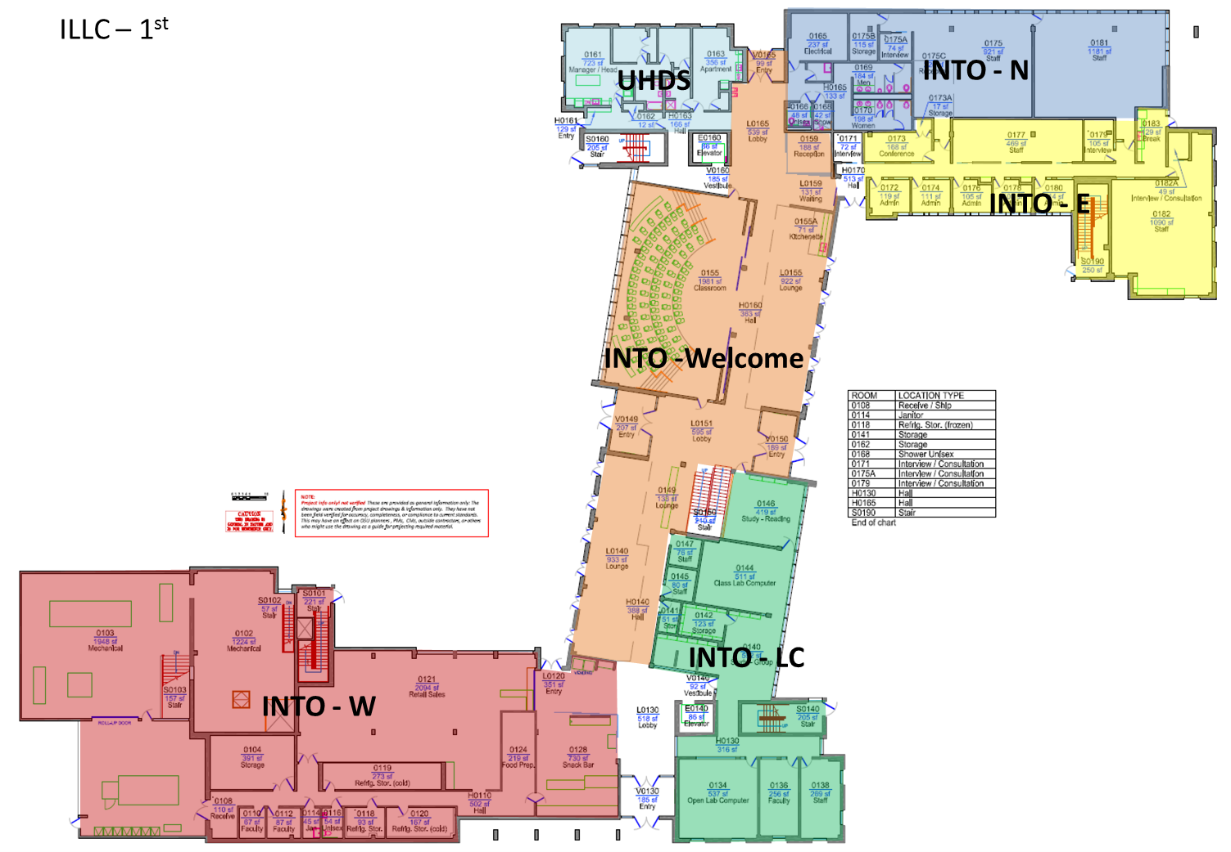

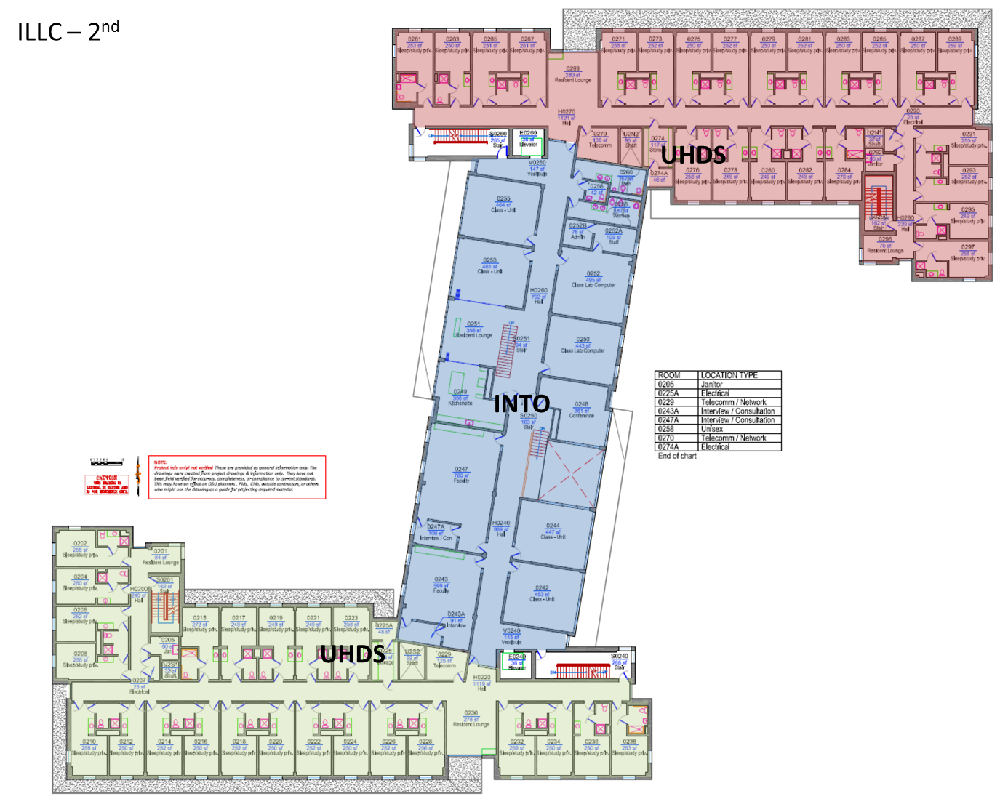

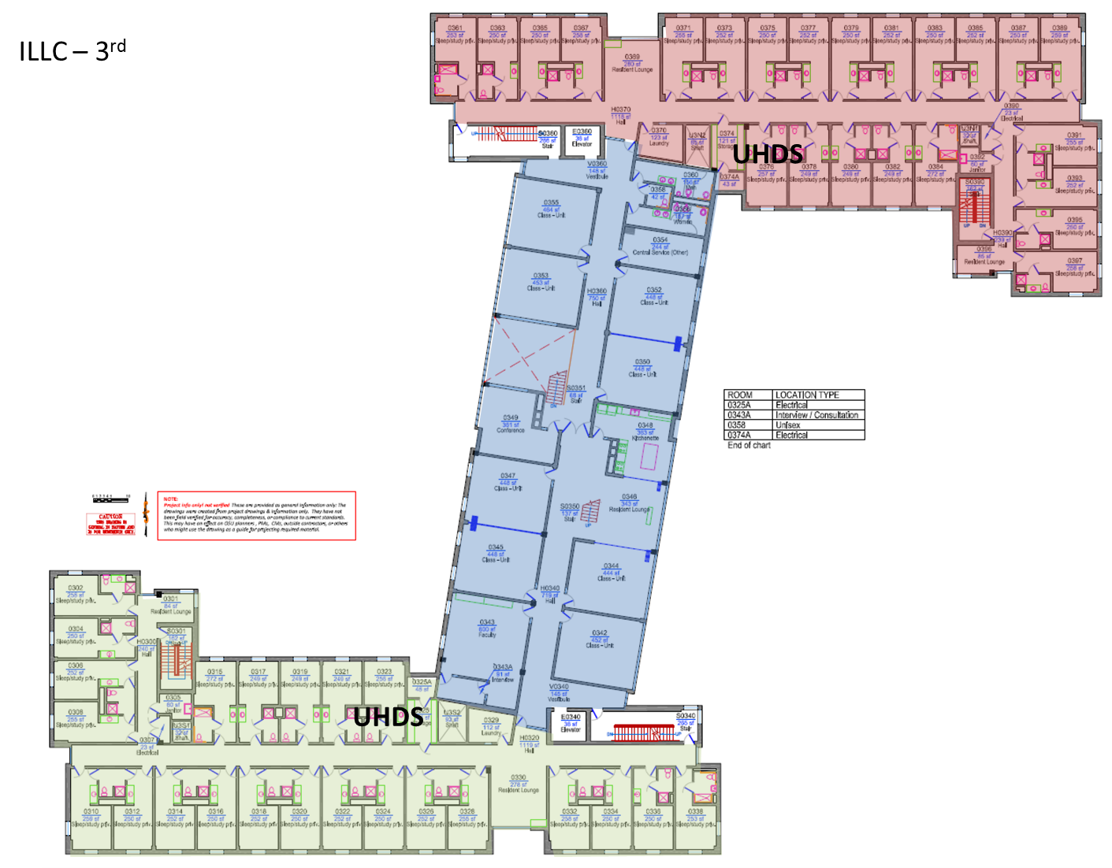

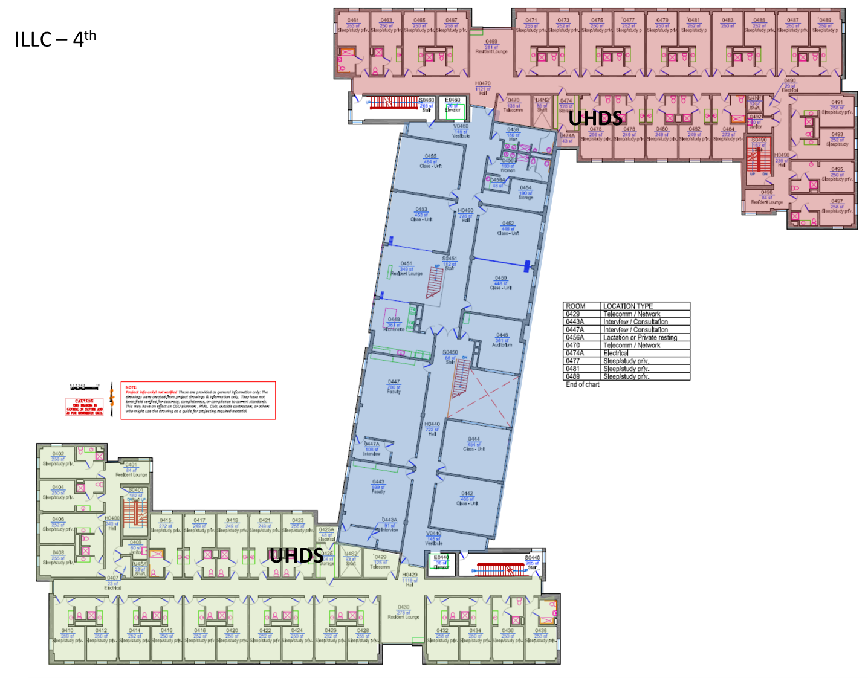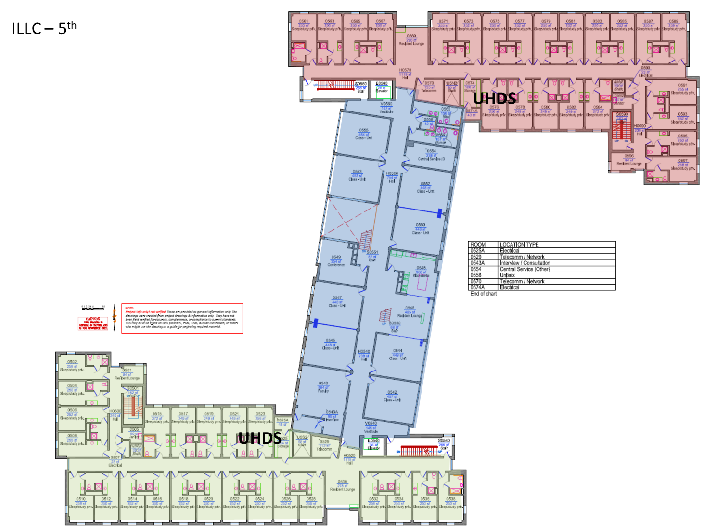

#### Evacuation Map (tsunami)



**Appendix F  
Emergency Action Plans**

## Shelter in place / Lock Down

**Mitigation:**

* Install locks or devices on doors that allow the door to be locked from the inside
* Obtain keys to lock exterior doors

**Preparedness:**

* Pre-identify interior locations that can be used for sheltering when stormy weather or violence strikes
* Identify how to isolate or turn off the air handling system OR select shelter locations that are not part of the air system
* Review with staff and faculty how to respond to acts of violence
  + Familiarize staff with any “safe” word that is used to communicate the situation to Public Safety
* Identify who has the capability and responsibility to lock exterior building doors

**Response:**

**Emergency: Call 7-7000**

When you receive the notice to seek shelter inside a building, or you decide to shelter due to a nearby outside danger (e.g. severe weather, outside environmental danger, or violent intruder):

1. Seek shelter inside a building and remain there.
   * If possible, seek shelter in areas without hazards (e.g. chemicals, fume hoods, water tanks, loose material, etc.)
   * If possible, warn anyone outside the building to immediately enter
   * Determine if a threat of violence is present and the building/occupants should lock internal and access doors.
2. If a weather incident, go to the lowest level of the building, stay in interior hallways, away from glass doors and windows.
3. If an outside chemical or hazardous material causes the sheltering, move everyone to the 2nd or 3rd floors of the building.
   * Close exterior doors and windows
   * Shut down the building’s air handling system
4. If a lock down situation:
   * If safe to do so, lock the exterior doors
   * Seek shelter inside a room that the door can be locked and barricaded
   * Lock the door and barricade it
   * Stay away from windows so no one can see you
   * Seek cover behind/under solid objects
   * Silence cell phones or other devices that make noise and could draw the intruder’s attention
5. If safe to do so, contact the following and report your situation:
   * 7-7000
   * INTO OSU leadership
6. Monitor TV or website news, if possible.
7. Wait for official notice to resume normal activities.
   * By OSUAlert notification
   * By person in hallway announcing all clear (it is acceptable to ask for official identification prior to unlocking the door)
   * Telephonic notification from the University
   * University website
8. Conduct accountability for personnel under your supervision.
9. Be prepared to conduct immediate evacuation if told to do so.
10. Report problems or concerns to INTO OSU leadership.

**Recovery:**

* Check in with INTO OSU leadership to determine response status
* Do not exit the building until allowed to do so

**Appendix F  
Emergency Action Plans**

## Fire/Explosion

Note: Refer to building specific Fire Safety Plan for detailed information

**Mitigation:**

* Store and handle flammable, combustible and other hazardous materials in accordance to OSU policies/procedures
  + [Environmental, Health and Safety](http://oregonstate.edu/ehs/) <http://oregonstate.edu/ehs/>
  + [OSU Safety Manual](http://oregonstate.edu/fa/manuals/saf/200) <http://oregonstate.edu/fa/manuals/saf>
* Maintain a tidy, waste free work area
* Conduct monthly room inspection of common areas to reduce fire hazards
* Participate in a required annual evacuation drills
* Identify staff/faculty responsibilities:
  + Building manager/floor monitor duties (Safety Manual Section 204 <http://oregonstate.edu/fa/manuals/saf/204>)
  + Faculty with students – ensure students under direct faculty supervision are evacuating
  + Employees required to stay behind and operate critical equipment prior to evacuating
* Report problems with fire safety systems immediately to the Work Coordination Center (WCC) 541-737-2969 or UHDS Work Center 541-737-2032.

**Preparedness:**

* Staff familiar with fire and life safety policies and responsibilities, to include use of portable fire extinguishers
* Identify the closest two exits to your work location
* Identify escape routes to the nearest exits
* Identify where the fire alarm pull station and fire extinguishers are located
* Know where the outside evacuation assembly point is for the building
* Report to INTO OSU Director any obstructions or limitations to the evacuation routes

**Response:**

**Fire Emergency: Call 9-1-1**

***Immediate procedures when fire, smoke, or an explosion is detected:***

1. Activate the nearest fire alarm pull station to alert building occupants and Public Safety
   * Fire alarm will sound (either a gong or electric chime)
   * Buildings equipped will also have strobe light activation to indicate an active fire alarm
2. Everyone leave the building immediately when an alarm sounds. Notify others around you of the evacuation, but do not delay your evacuation
3. If time allows and you can perform the action without endangering yourself:
   * place the equipment you are operating into a safe configuration before evacuating
   * close doors and windows before evacuating, if this can be accomplished quickly and safety. It is particularly important to close doors to contain the fire in the room/area of origin.
4. Evacuate through the nearest safest exit
   * See Appendix F – Emergency Action Plans: Evacuation
5. Call 9-1-1 to report the fire alarm, after evacuating building.
6. Do not re-enter the building until fire or police give permission to do so.
7. Move to evacuation assembly area (See Appendix F – Evacuation or building emergency plan). If evacuation area cannot be reached or is unknown, move as far away from the building as practical, so as not to be in danger or in the way of emergency responders. (a minimum of 50 feet)
8. Once safely outside, check to make sure no one is missing, and inform emergency responders/Building Manager/INTO OSU Leadership if someone is unaccounted for.
9. Do not use elevators during an evacuation.
10. If evacuation routes are blocked, remain in your room, stand by a window, and call 9-1-1 to report your location, and wait for fire department assistance.

If your building is equipped with a fire escape, all other exit routes are blocked, and you cannot wait for the fire department to rescue you from a window area, proceed with caution down the fire escape.

1. Individuals with mobility or evacuation concerns:
2. Students, staff and visitors who are blind should be assisted through hallways and down stairways
3. Wheelchair bound persons should follow evacuation routes on the ground floor of a building. If not on the ground floor, wheel to the nearest assembly area (fire escape or stairway door). Rescue personnel will search these areas first, and help individuals with disabilities evacuate the building.
   * If no pre-identified area, go to an area that provides a barrier between you and the hazard
   * Communicate with responders
   * Dial 9-1-1 or OSU Public Safety (737-7000)
   * Place a cloth or clothing out a window to attract attention
   * Notify others who are evacuating to inform responders of your location
4. Staff/Faculty are not required to attempt to fight a fire. If you are trained to do so, and can safely do so, use the appropriate fire extinguisher to attempt to extinguish small fires (office trash can size). Ensure 9-1-1 has been called prior to attempting to extinguish the fire.

**Recovery:**

* Check in with INTO OSU Leadership to determine response status
* Do not enter a building until allowed to do so
* Once entering the building, inspect your work area and report any issues
* If food services are involved, the County Health Department is required to inspect the food service area before food service can be conducted
* Contact EH&S (541-737-2273) for additional monitoring or questions regarding the work environment after a fire incident
* Contact UHDS Work Center (541-737-2032) to schedule or verify that repair work is being conducted

**Appendix F  
Emergency Action Plans**

## Medical Injury

**Mitigation:**

* Conduct a Job Hazard Analysis to identify work that could potentially cause injuries. Develop a plan to reduce the risk of injury
* Train personnel in First Aid and CPR
* Purchase an Automated External Defibrillator (AED)
* Develop an emergency medical plan if emergency medical help is greater than 30 minutes away
  + Identify communication method to emergency responders
  + Identify transportation to a point where the ambulance can be met
  + Have a first aid trained person available and identified to workers
  + Have a first aid kit in close proximity to workers

**Preparedness:**

* Know where the workplace medical response items are (first aid kit, AED, PPE…)
* Know who in your work group is trained in first aid
* Review with co-workers the response actions to potential work place injuries

**Response:**

**Medical Emergency: Call 9-1-1**

**OSP: 541-737-7000**

1. Remain calm, initiate lifesaving measures if required.
2. Do not move injured person unless there is danger for further harm.
3. Call 9-1-1 for emergency medical assistance. Also call OSU Public Safety for notification and assistance.
4. Call out for help so others nearby can respond to the incident
5. Call or send someone to call 9-1-1 for Emergency Medical services (dial 9-1-1).
6. Give your name, location, and telephone number. Provide as much information as possible regarding the nature of the injury, or illness, and whether or not the victim is conscious, etc.
7. Provide first-aid
8. Administer first aid (if properly trained)
9. Keep the victim as comfortable as possible
10. Remain with the victim until the assistance arrives.
11. DO NOT give fluids or food unless authorized by a medical provider
12. Protect yourself from potential blood borne pathogens (human blood and other body fluids.)
13. Protect yourself against exposure to hazardous materials. Consult the Safety Data Sheet and wear appropriate personnel protective equipment.
14. Send someone to meet the ambulance and guide it to the patient

**Recovery:**

* If the injured person is an employee, contact the employee’s supervisor and initiate the reporting procedures as directed.
* If you think you have been exposed to bodily fluids:
  + Seek medical treatment from your physician or other health care provider
  + Report the exposure to your supervisor, who will complete the web based HR Advocate Incident Reporting (<http://hr.oregonstate.edu/benefits/workers-compensation-resources>) and Form 801 (Report of Accident/Illness)
  + Contact the OSU Biological Safety Officer (541-737-4557)

**Appendix F  
Emergency Action Plans**

## Poisoning

**Mitigation:**

* Review the types and purpose of poisonous materials and properly dispose of if no longer needed or replace with a less poisonous substance.
* Properly label poisonous materials and ensure labeling is legible

**Preparedness:**

* Ensure personnel using poisonous materials are familiar with the hazards and appropriate response
* Consult the Safety Data Sheet and wear appropriate personnel protective equipment.

**Response:**

**Poison Control Center: Call 1-800-452-7165**

**Fire/Ambulance: Call 9-1-1**

**Police: Call 7-7000**

If poison is splashed in eyes:

1. Call out for help so others can come to you
2. Rinse eyes with running water for up to 15 minutes, Hold the eyelid open while water flows over the eyeballs. Do not rub the eye.
3. Call 9-1-1 for medical assistance, if needed
4. Call Poison Control Center
5. Contact employee’s supervisor
6. Contact appropriate INTO OSU Manager.
   1. Care and Conduct Coordinator
   2. Joint Venture representative
   3. OSU Human Resources
7. Protect yourself against exposure to hazardous materials.

If poison is splashed on skin:

1. Call out for help so others can come to you
2. Take off any splashed clothing, rinse skin with running water for up to 15 minutes.
3. Call 9-1-1 for medical assistance, if needed
4. Call Poison Control Center
5. Contact employee’s supervisor
6. Contact appropriate INTO OSU Manager.
   1. Care and Conduct Coordinator
   2. Joint Venture representative
   3. OSU Human Resources

If poison is inhaled:

1. Call out for help so others can come to you
2. Get patient to fresh air, open doors and windows
3. Call Poison Control Center, 1-800-452-7165
4. Contact appropriate INTO OSU Manager.
   1. Care and Conduct Coordinator
   2. Joint Venture representative
   3. OSU Human Resources
5. Contact employee’s supervisor
6. Protect yourself against exposure to hazardous materials. Consult the Safety Data Sheet and wear appropriate personnel protective equipment.

If poison is ingested:

1. Call out for help so others can come to you
2. Call 9-1-1 for medical assistance, if needed
3. Call Poison Control Center
4. If cleaning product is swallowed, prepare to give one glass of water or milk to drink, under the direction of the Poison Control Center (unless person is unconscious, having convulsions or is unable to swallow).
5. Contact appropriate INTO OSU Manager.
   1. Care and Conduct Coordinator
   2. Joint Venture representative
   3. OSU Human Resources
6. Contact employee’s supervisor

**Recovery:**

* Follow spill response procedures to clean up chemical and rinse water
* If the injured person is an employee, contact the employee’s supervisor and initiate the reporting procedures as directed. (HR Advocate web site <http://hr.oregonstate.edu/benefits/workers-compensation-resources> and Form 801 (Report of Accident/Illness))

**Appendix F  
Emergency Action Plans**

## Chemical Spill

**Mitigation:**

* Identify and obtain spill response materials, based on the chemical substance being used (to include PPE)
* Develop a spill response plan specific to the chemical being used

**Preparedness:**

* Know the chemical information prior to working with the chemical
* Review the latest Safety Data Sheet (SDS)
* Know the hazards of the chemical
* Have and use the appropriate PPE before using the chemical
* Know the spill response plan to the chemical

**Response:**

**Medical Response: Call 9-1-1**

**HAZMAT Response: Call 9-1-1**

**OSU Public Safety Response: 41-737-3000 (emergency) 541-737-3010 (non-emergency)**

**Hazardous Material Spill Response: OSU Environmental Health and Safety: 541-737-2273**

**Work Coordination Center: 541-737-2969 (routine, non-emergency service)**

1. Alert people in the immediate area to evacuate; close doors to affected area
2. Determine the size of the spill and respond appropriately, according to the spill response plan
   * Immediately evacuate the area if you are not equipped to mitigate the spill
   * Don personal protective equipment
   * Obtain spill control materials
   * Contain the spill
   * Dispose of material correctly
3. Attend to injured or contaminated person if safe to do so
4. Have person with knowledge of incident or area assist responding emergency personnel

***Additional information*:**

1. Some emergencies require the evacuation of the buildings. The sounding of the fire alarm system or verbal orders in the building will signal evacuation.
   1. See Appendix E – Emergency Response Procedures: Evacuation
2. Check to make sure no one is missing, and inform emergency responders if someone is unaccounted for.
3. Do not use elevators during an evacuation.

**Recovery:**

* Follow spill response procedures to clean up water and chemical waste
* Report spills to Environmental Health and Safety for assistance with regulatory reporting

**Appendix F  
Emergency Action Plans**

## Radiological Material Spill

**Mitigation:**

* Store all radioactive liquids in secondary containment
* Perform work in spill containment trays and/or on benches lined with plastic-backed absorbent paper

**Preparedness:**

* Review radiation response plan
* Remain current in Radiation Safety Training

**Response:**

**Fire Department: Call 9-1-1**

**OSU Radiation Safety: Call 541-737-2227**

**OSU Environmental Health and Safety: Call 541-737-2273**

**OSU Public Safety Response: Call 541-737-300 (emergency ) 541-737-3010 (non-emergency)**

**Work Coordination Center: 541-737-2969 (routine, non-emergency service)**

1. Evacuate area if health risk exists.
2. Administer first aid if properly trained.
3. Notify OSU Radiation Safety
4. Notify 9-1-1 (if needed).
5. Contain spill if safe to do so.

***Additional information*:**

Spreading of radioactive material beyond the spill area can easily occur by movement of personnel involved in the spill, or clean-up effort. Prevent spread by confining movement of personnel until they have been monitored and found free of contamination. A minor radioactive material spill is one that the laboratory is capable of handling safely without the assistance of safety, or emergency personnel. All other radioactive releases are considered major.

**Minor Radioactive Material Spill:**

1. Alert people in the immediate area of the spill.
2. Notify Radiation Safety
3. Wear protective equipment, including safety goggles, disposable gloves, shoe covers, and long sleeve lab coat.
4. Place absorbent paper towels over liquid spill. Place towels dampened with water over solid material.
5. Monitor area, hands, and shoes for contamination with and appropriate survey meter, or method.

**Major Radioactive Spill:**

1. Attend to injured or contaminated persons and remove them from exposure.
2. Have potentially contaminated personnel stay in one area until they have been monitored and shown to be free of contamination.
3. Alert persons in laboratory to evacuate. Do not cross potentially contaminated paths. Personnel that think they are contaminated should segregate themselves from non-contaminated personnel.
4. Notify 9-1-1, if needed
5. Notify OSU Radiation Safety
6. Close doors and prevent entrance into effected area.
7. Have personnel knowledgeable of incident and laboratory assist emergency response personnel.

**Recovery:**

* Follow Radiation Safety guidance spill response procedures to clean up
* Report spills to Environmental Health and Safety for assistance with regulatory reporting

**Appendix F  
Emergency Action Plans**

## Transportation Accidents

**Mitigation:**

* Complete required training or paperwork prior to traveling

**Preparedness:**

* Review the road conditions before traveling
* National Weather Service <http://www.wrh.noaa.gov/pqr/>
* ODOT Tripcheck <http://tripcheck.com/Pages/RCMap.asp?curRegion=0>
* Inspect the vehicle prior to departure
* Snow chains (if applicable)
* Vehicle emergency kit
* Walk around and observe vehicle for any operating concerns
* Observe nearby hazards prior to moving vehicle
* Adjust mirrors, seat, and steering wheel for proper use

**Response:**

Medical Response: Call 9-1-1

Fire Response: Call 9-1-1

Law Enforcement:

On Campus: 541-737-7000

Off Campus: Call 9-1-1

**OSU Public Safety/Security Response: Call 541-737-3010**

**OSU Motorpool: Call 1-866-253-5671**

**OSU Risk Management: Call 541-737-77350**

1. Stop and assess the situation
2. Call 9-1-1 if there are medical or fire concerns
3. Call 9-1-1 to request law enforcement assistance
4. Place emergency lights/flares on roadway to warn on-coming traffic
   * If directed by responders, move the vehicle to the side of the road
5. Request that law enforcement file a written report
6. Follow OSU accident reporting procedures (found in OSU vehicle) <http://motorpool.oregonstate.edu/vehicles/accidents-and-assistance>
7. Contact Risk Management at 541-737-7350 to report ALL accidents regardless of the amount of damage.

**Recovery:**

* Report the accident, to the University Motor Pool by calling (866) 253-5671 and submit the **State Self Insurance Claim** form
* Within 72 hours, fill out the DMV Accident Report form if there were any of the following: 1) injury resulting from the accident, 2) damages exceeding $1,500, or 3) if the vehicle needed to be towed
* Report the accident to your manager
* If an OSU employee is involved in the accident, complete the web based HR Advocate Incident reporting <http://hr.oregonstate.edu/benefits/workers-compensation-resources>
* If an OSU employee is injured, complete a Form 801 (Report of Accident/Illness) and the web based HR Advocate Incident reporting (<http://hr.oregonstate.edu/benefits/workers-compensation-resources>)

**Appendix F  
Emergency Action Plans**

## Severe Weather

(lightning, high winds, flooding, heat, cold, snow)

**Mitigation:**

* Conduct risk analysis of INTO OSU outside operations
* Develop personnel safety threshold criteria for automatic protective actions
* Develop incident safety threshold criteria for automatic cancellation or implementation of protective actions
* Review INTO OSU weather related events and their impact upon operations

**Preparedness:**

* Review work plan and weather response criteria prior to outside work
  + FEMA Informational web site <http://www.ready.gov/natural-disasters>
  + National Weather Service <http://www.weather.gov/safety>
* Know how to reach the nearest safe area for a weather incident
* Obtain appropriate response equipment for weather related events
* Seasonally, review weather related information to better prepare for events

**Response:**

* Heat
  + Hydrate
  + Monitor work/rest level
  + Avoid sunshine/create shade
  + Monitor health of animals
* Lightning
  + Avoid contact with corded devices or electrical equipment
  + Avoid contact with plumbing
  + Stay away from windows
  + Avoid tall objects/natural lightning rods
  + Take shelter in a sturdy building
  + Take shelter in an automobile. Avoid touching metal surfaces.
* High Winds
  + Seek shelter indoors
    - Move away from glass windows
    - Avoid blowing debris
  + Secure loose objects that may blow away
  + Identify safe areas to move to incase the winds become extreme
* Flooding
  + Monitor area for rising water
  + Do not drive through flooded areas
  + Do not walk through moving water
  + Do not park near steams or other waterways
* Winter Storms (ice/snow/cold)
  + Stay indoors during the storm. Monitor weather service forecasts
    - NOAA – Portland Office <http://www.wrh.noaa.gov/pqr/>
  + Dress appropriately
    - Dress in layers
    - Keep dry
  + Open cabinet doors/office doors to allow heat to circulate in closed spaces
  + Unless pre-approved, DO NOT burn materials inside of buildings to create heat (e.g. kerosene heaters, BBQs, candles)

**Recovery:**

* Check on welfare of fellow staff/faculty/students
* Review work place for post-incident damage. Contact UHDS work Center (737-2032) to request repair
* Review incident response and adjust response plan if necessary

**Appendix F  
Emergency Action Plans**

## Earthquake/Tsunami

**Mitigation:**

* Secure, or ask UHDS Work Center (737-2032) to secure items in your office or work area that would be a hazard in an earthquake (e.g. bookcases, water coolers, etc.)
* Identify safe spots in each room to Drop, Cover, and Hold
* Participate in earthquake drills
* Conduct off-site data backup of essential information

**Preparedness:**

Preparation tips for workplace emergency evacuation:

* Think through your evacuation scenario from different parts of the campus or your commute and be familiar with the tsunami evacuation route map
* Frequently review the earthquake Emergency Action Plan and the DO NOTs noted
* Have a backpack ready with emergency gear; see www.redcross.org for details. Routinely store (if practical) your coat, hat, phone, and essentials (e.g. handbag) where they can be accessed easily.
* Be prepared, but also be mentally prepared to leave everything behind if not readily accessible. Timely evacuation is a higher priority than emergency supplies or personal items.
* Prepare a communication plan for your family. Keep in mind that your home may not be structurally sound.
* Preprogram essential phone numbers and alerts into cell phones and other devices
* Develop a habit of noting your whereabouts outside your door (e.g. gone for the day; on leave until Thursday). This will prevent others from looking for you unnecessarily.

Work Neighborhoods:

* Staff members are encouraged to communicate with individuals along their hallway or section of the building. Self-designated ‘work neighborhoods’ may be formed on a voluntary basis (e.g. west wing, east wing).
* Meet with your ‘neighbors’ to talk through evacuation. Focus especially on the first few minutes after the shaking stops.
* Some topics to discuss are checking on neighbors, grabbing gear for neighbors if they are not in their offices; drilling as a group; designating a meeting spot; what to do about injured/trapped coworkers; recording your whereabouts regularly outside your door; keeping contact #’s for the group in your backpack.
* Respect, but note, individuals’ wishes (e.g. to opt out of the group, or to meet up with family members instead)

Managers:

* Impress upon your staff that regardless of how slight the shaking might seem, they are expected to evacuate when it is safe to do so in case of any earthquake.
* Brief visitors including students and others working at INTO OSU
* Encourage staff to consider evacuation routes when planning and implementing field research.
* Be prepared to contact staff in the event of a tsunami or other evacuation in the absence of warning signs (e.g. shaking).

All Personnel:

* Remember you have 15 min or less to reach a tsunami assembly area.
* DO NOT go back to your office or spend time packing; grab your emergency gear ONLY if it is handy. Evacuate to higher ground immediately.
* DO NOT wait for an official warning. Evacuate even if the shaking is slight.
* DO NOT re-enter buildings. You will not have time, and they may be unstable.
* DO NOT return to the campus until an “all clear” from local officials has been issued; beware of unfounded rumors of an all-clear.

**Response:**

**If you feel an earthquake:**

1. Protect yourself (Drop, Cover and Hold-on). Evacuate the building as soon as you deem it safe.
   * Stay away from glass
   * Do not use a doorway unless you know it is a load-bearing doorway
   * Do not exit the building while shaking is going on. Falling debris can kill you
   * Do not use elevators
   * Do not pull fire alarm
2. If outside during the shaking, move away from buildings or other objects that could fall
3. Bring only items you can easily grab, including backpacks especially packed with emergency gear, coat, hat, phone, essentials (e.g. handbag).

**Recovery:**

* Do not re-enter a building until it has been seismically inspected
* Expect aftershocks and more building damage to occur
* Extinguish small fires
* Follow OSU guidance for follow-on activities.

**Appendix F  
Emergency Action Plans**

## Building Systems (Utilities)

(gas, water, sewer, electrical)

**Mitigation:**

* Identify utility cutoff switches/valves and who can operate them
* Coordinate with Facility Operations for pre-planning of response events

**Preparedness:**

* Train personnel on response to different types of utility failures
  + When to evacuate
  + When building access will be denied

**Response:**

Work Coordination Center: 541-737-2969

OSU Public Safety: 541-737-3010

Environmental Health & Safety: 541-737-2273

In the event of extended utility loss (power, water, sewage, etc.) to a facility, certain precautionary measures should be taken depending on the geographical location and environment of the facility:

1. Evacuate the building if necessary
   1. Lab hood ventilation is lost
   2. Power is lost
2. Contact the Work Coordination Center (541-737-2969) to report the problem
3. Ensure the backup generator has started
4. If stuck in the elevator, use the elevator intercom to request assistance
   1. Remain calm
   2. Call out for help if the intercom does not work
   3. DO NOT attempt to exit the elevator without emergency responders present
5. Be prepared to provide fire monitors if occupancy is permitted during a utility outage
6. Building re-entry:
   1. If the building DOES NOT have a backup generator, and the life safety/fire detection system is not powered, a Fire Watch has to be implemented if the building is to be re-occupied while the power is out. A Fire Watch must:
      1. Be competent to identify fire hazards
      2. Be able to communicate to the fire department if a response is needed
      3. Be familiar with the structure and emergency plan
      4. Perform patrols every 15 minutes to look for instances of fire
      5. Keep a log sheet: Person’s name, time each activity was conducted, description of activity
   2. If the building has a backup generator that powers the life safety/fire detection systems, confirm the generator is running and re-occupy the building.
   3. If the building has laboratory hoods, contact EH&S (737-2273) for habitability evaluation prior to any building occupancy.

**Recovery:**

1. Electronic equipment should be brought up to ambient temperatures before energizing to prevent condensate from forming on circuitry.
2. Fire and potable water piping should be checked for leaks from freeze damage after the heat has been restored to the facility and water turned back on.

**Appendix F  
Emergency Action Plans**

## Crimes in Progress

**Mitigation:**

**Preparedness:**

**Response:**

**Police: Call 7-7000**

1. Move to a safe location.

* Do not attempt to apprehend or interfere with the criminal except in case of self-protection.

1. Call the police at 7-7000.
2. Remain calm, tell the dispatcher where you are calling from, what has happened, and give your name and the phone number to call you back.

* If safe to do so, attempt to get a good description of the criminal. If the criminal is entering a vehicle, note the license number, make, model, color, and outstanding characteristics of the vehicle. Answer all questions asked. Remain on the telephone until dispatcher releases the call.

1. In the event of a civil disturbance, after you have contacted 9-1-1, contact Public Safety. Continue as much as possible with your normal routine. If the disturbance is outside, stay away from doors and windows.
2. Meet police when they arrive, if safe to do so.

* Do not interfere with those persons creating the disturbance, or with authorities on scene.

**Recovery:**

* Cooperate with law enforcement

**Appendix F  
Emergency Action Plans**

## Sexual Assault

**Mitigation:**

**Preparedness:**

**Response:**

**Police: Call 7-7000**

**Emergency Medical Response: Call 9-1-1**

**Center Against Rape and Domestic Violence: 541-754-0110**

**Survivor Support: 541-754-0110, 1-800-927-0197**

**Sexual Assault Support Services (SASS) helpline: 541-737-7604**

**OSU Department of Public Safety Emergency: Call 737-7000**

1. React early - fight for your life, strike eyes, throat, and groin. Pull your attacker’s hair.
2. Yell “Fire” to draw attention to you.
3. Run away to a place where there are other people.
4. Call the police, 9-1-1.
5. Preserve evidence - do not wash your clothes, shower, douche, or clean the area where the crime was committed.

**Recovery:**

* Check in with supervisor for access to OSU support systems

**Appendix F  
Emergency Action Plans**

## Active Shooter

**Mitigation:**

* Install locks or devices on doors that allow the door to be locked from the inside
* Obtain keys to lock exterior doors

**Preparedness:**

* Review with staff and faculty how to respond to acts of violence
  + Watch the Run, Hide, Fight video <http://www.youtube.com/watch?v=5VcSwejU2D0>
  + Familiarize staff with any “safe” word that is used to communicate the situation to Public Safety
* Identify who has the capability and responsibility to lock exterior building doors
* An active shooter is a person or persons who appear to be actively engaged in killing or attempting to kill people in populated areas on the campus. Active shooter situations are dynamic and evolve rapidly, demanding immediate response by the community and immediate deployment of law enforcement resources to stop the shooting and prevent harm to the community. Be aware that the emergency phone lines become overwhelmed in this type of situation.
* Know the response by law enforcement
  + They will by-pass wounded and anyone else as they go directly to the shooter
  + They evaluate every person as a shooter. Keep your hands above your waist, stay on the floor, do not distract the responder from finding the shooter.
  + When directed out of the building, keep your hands empty, keep them above your head and move quickly in the direction responders tell you.

**Response:**

**Police: Call 7-7000**

**Emergency Medical Response: Call 9-1-1**

**If an active shooter is outside your building or inside the building you are in, you should:**

1. Try to remain calm.
2. Try to warn faculty, staff, students, and visitors to run away
   1. Have one person call 7-7000 and provide: “this is (name), (give your location) and we have an active shooter at (building on OSU campus) gun shots fired.” If you are able to see the offender(s), give a description of the person(s) sex, race, clothing, type of weapon(s), location last seen, direction of travel, and identity – if known.
   2. If you have observed any victims, give a description of the location seen and a description.
3. If you cannot run away, seek immediate shelter.
   1. Proceed to a room that can be locked or barricaded.
   2. Lock and barricade doors and windows. Turn off lights. Close blinds. Block windows.
   3. Turn off radios and other devices that emit sound.
   4. Keep yourself out of sight and take adequate cover/protection, e.g. hide inside a closet, get behind concrete walls, thick desks, filing cabinets, or any other object that will stop a bullet penetration.
   5. Stay close to the ground after locking the door and finding a hiding place
   6. Silence cell phones.
   7. Have one person call 7-7000 and provide: “this is (name), (give your location) and we have an active shooter at (building on OSU campus) gun shots fired.” If you are able to see the offender(s), give a description of the person(s) sex, race, clothing, type of weapon(s), location last seen, direction of travel, and identity – if known.
   8. If you have observed any victims, give a description of the location seen and a description.
   9. If you observed any suspicious devices (improvised explosive devices), provide the location seen and description.
   10. If you heard any explosions, provide a description and location.
4. Wait patiently until a uniformed police officer, or an OSU official provides an “all clear”. Ask for identification to confirm the responder’s status.
5. Unfamiliar voices may be an active shooter trying to lure you from safety; do not respond to commands until you can verify with certainty that they are being issued be a police officer, or OSU official.
6. Rescue of people should only be attempted if it can be accomplished without further endangering the persons inside the secure area.
7. Depending on circumstances, consideration may also be given to exiting ground floor windows as safely and quietly as possible.
8. If a lockdown is implemented, no one will be allowed enter or leave the building.

**If an active shooter enters your office or classroom, you should:**

1. Arm yourself with any kind of weapon possible
2. Fight for your life

**If you are in an outside location and encounter and active shooter, you should:**

1. Try to remain calm.
2. Move away from the active shooter or sounds of the gunshot(s) and/or explosion(s).
3. Look for appropriate locations for cover/protection, e.g. brick walls, retaining walls, large trees, parked vehicles, or any other object that may stop bullet penetration.
4. Try to warn other faculty, staff, students, and visitors to take immediate cover.
5. Call 7-7000 and provide the information listed in the first guideline.

**Recovery:**

* Be prepared to be interviewed by officials
* Contact your supervisor to seek counseling services

**Appendix F  
Emergency Action Plans**

## Hostage

**Mitigation:**

**Preparedness:**

**Response:**

**What to do if taken hostage:**

1. Be patient. Time is on your side. Avoid drastic action.
2. The first 45 minutes are the most dangerous. Be alert and follow instructions.
3. Do not speak unless spoken to and then only when necessary.
4. Avoid arguments, or appearing hostile. Treat the captor with respect. If you can, establish a rapport with the captor. It is probable the captors do not want to hurt anyone. If medications, first aid, or restroom privileges are needed by anyone, say so.
5. Try to rest. Avoid speculating. Expect the unexpected.
6. Be observant. You may be released or escape. You can help others with your observations.
7. Be prepared to speak to law enforcement personnel on the phone.

**Recovery:**

* Be prepared to be interviewed by officials
* Contact your supervisor to seek counseling services

**Appendix F  
Emergency Action Plans**

## Bomb Threat

**Mitigation:**

**Preparedness:**

* Periodically review bomb threat checklist
* Have access to a copy (electronically or paper copy) that can be completed during/after the phone call

**Response:**

**Police: Call 7-7000**

1. Keep the caller on the phone as long as possible
2. Get detailed information from caller (use Bomb Threat Checklist)
3. Look at telephone display, if equipped, write down the number.
4. Have someone call OSU Public Safety Dispatch from a separate phone

* Give your name, location and telephone number. Inform Public Safety of the situation
* Include any information you may have as to the location of the bomb, time it is set to detonate, and the time you received the call.
* Do not hang up until the dispatcher releases you from the conversation or if you feel threatened to remain on the phone in your current location

1. Inform your supervisor and /or department head. Indicate to your supervisor that you have notified OSU Public Safety.
2. Inform INTO OSU Executive Director
3. Evacuate if directed to do so.

* If you should spot a suspicious object, package, etc., report to Public Safety. Do not touch, tamper, or move it in any way. Then contact the Director’s Office.

**Recovery:**

* Be prepared to be interviewed by officials
* Contact your supervisor to seek counseling services

#### Bomb Threat Checklist

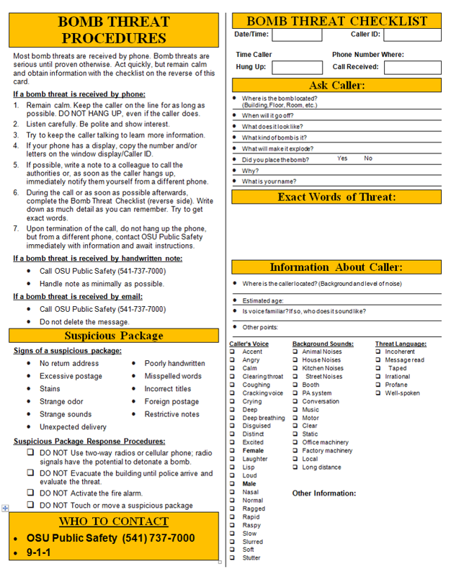

**Appendix F  
Emergency Action Plans**

## Bomb/Suspicious Object

**Mitigation:**

* Keep work area clean and clutter free so that suspicious objects can be quickly noticed

**Preparedness:**

* If a mail handler, review the criteria for identifying a suspicious package
  + USPS <http://about.usps.com/publications/pub166/pub166_tech_015.htm>
* Post the suspicious package poster in the mail handling area
  + USPS <http://about.usps.com/posters/pos84.pdf>

**Response:**

Police: Call 7-7000

1. Do not touch the device
2. Immediately evacuate the area to the evacuation point
   1. Look for other objects as you depart
   2. Look around evacuation area for other suspicious objects
3. Do not use cellular or radio communication within 100 feet of the device
4. Evacuate others in the vicinity
5. Call OSU Public Safety Dispatch to report the suspicious object
6. Be prepared to move farther away, if so directed by law enforcement

Recovery:

* Be prepared to be interviewed by officials
* Contact your supervisor to seek counseling services

**Appendix F  
Emergency Action Plans**

## Disruptive Student

**Mitigation:**

**Preparedness:**

* Review with staff and faculty how to respond to acts of violence
  + Watch the Run, Hide, Fight video <http://www.youtube.com/watch?v=5VcSwejU2D0>
  + Familiarize staff with any “safe” word that is used to communicate the situation to Public Safety
* There are times when behavior is so disruptive that an immediate referral to The Office of Student Conduct and Mediation is appropriate. The term “classroom disruption” means behavior a reasonable person would view as interfering with the conduct of the class. Examples of increasing seriousness include:
  + Making distracting noises
  + Persistently speaking without being recognized
  + Repeatedly interrupting
  + Resorting to physical threats, or personal insults.
* Learn the symptoms of a distressed student
  + Faculty and staff can play an extremely important role in referring students for help. You are frequently in a position to first observe signs of distress and, although it is not always apparent, students typically hold faculty and staff in high regard.

**Signs that a student is distressed include:**

1. Excessive class absences
2. Declining academic performance
3. Poor emotional control
4. Excessive moodiness
5. Sleeping, and/or eating habits that change dramatically
6. Excessive concern about personal health, persistent depression
7. Talking openly about suicide
8. Repeatedly engaging in risky behavior.

* Learn the response to intervening to a potentially distressed student
  + A simple and straightforward expression of concern in most cases is the most powerful way of helping a student. Tell them what you have observed and that you are concerned about their well-being and their success. Explain there are services available on campus to help students get back on track when life circumstances are getting in the way. In some cases, it might be helpful to assist the student in getting touch with OSU Counseling services in Snell Hall, or call to let the office know that a student will be getting in touch with them. Assure the student that counseling services is a confidential place to discuss their concerns.
  + If you are unsure about whether or how to intervene with a student who appears to be distressed, ask yourself the following questions;

1. Is the student’s behavior distressingly out of the ordinary?
2. Is this beyond my skill level?
3. Is this student’s behavior getting worse?
4. Am I feeling like I want to talk with someone about my observations and concerns?
5. Does the behavior place anyone at immediate risk?

If you answer “yes” to any of these questions, it is probably a good idea to consult with a colleague. Call the University Counseling and & Psychological Services (541-737-2131), and ask to talk with the on-call counselor. If that person is not immediately available, and you do not feel you can wait, ask if someone else is available for consultation. UCPS can help you evaluate the situation and assist you in considering your options for intervention.

**Response:**

**OSU Department of Public Safety Emergency: Call 737-7000**

1. When a very serious or threatening incident of disruptive behavior occurs in the classroom, academic building, or on the OSU campus, OR the behavior places anyone at immediate risk, call Public Safety Dispatch immediately.

Recovery:

* Be prepared to be interviewed by officials
* Contact your supervisor to seek counseling services